 | Enrichment Days Preference Form 2020

You must ensure that this form is completed and signed in all circumstances and returned back to the Academy Reception. Make that you only book activities which are open to your child’s year group and that you check the day and costs involved carefully. Payments must be made via ParentMail. Instructions on how to do this are within the information booklet that has been provided with this form. FINAL PAYMENT DEADLINE is Thursday 2nd APRIL 2020.
Please follow the instructions in the booklet provided.
Student Number: | ………………………………………..
Student Name: | ………………………………………..
Form Group: | ………………………………………..






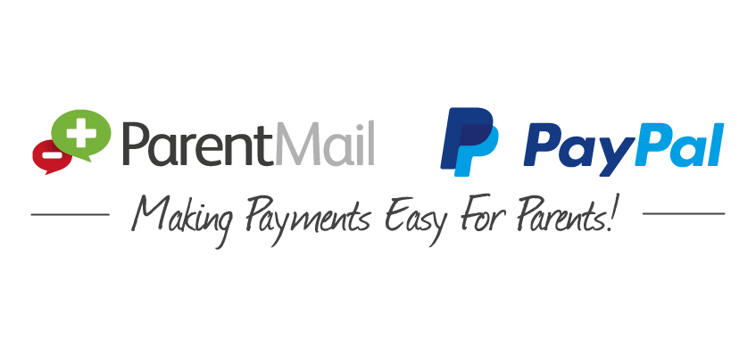
Allocations will be made on a first come first served basis and an alternative may have to be offered. This is why we ask you to select three choices for each day.
Online Payments

Please insert the name of the activity (as stated in the Booklet or on the Activity Sheet List) in the correct column for the specific day, in order of preference. I would like my child to participate in the following activities:

Preference | Monday 13th July | Tuesday 14th July | Wednesday 15th July | Thursday 16th July
1st Choice
2nd Choice
3rd Choice

Please read and tick ‘Yes’ to confirm you have understood the following

□ Yes | I understand that deposits and balances are non-refundable.
□ Yes | I have read the information in the booklet and I understand that if my child does not behave in an appropriate manner they may lose their place on the trips and activities.
□ Yes | I understand all remaining money must be paid by Thursday 2nd April 2020.
□ Yes | I understand that a deposit for a second or third trip cannot be used to pay for another trip at a later date.

Please return this completed form and money (where applicable) to the Academy Reception by Friday 14th February 2020. This should be placed in the sealed envelope that has been provided with this letter.

Parent/Guardian Signature: …………………………………………………………………….. Date: …………………………...
Parent Email: ……………………………………………………………………………………………………………………………………..

We would like to use your email address for to keep in contact with you and for Academy Apps such as MyEd and ParentMail*, are you happy for us to use your email address for these purposes? □ Yes □ No
*Further information about Academy Apps is available on our website www.josephleckieacademy.co.uk
Online Payments

