Improving our Vocabulary Videos (part 1) 11.05.20
Proficiency A videos A
Watch these videos, they will help you to increase your English vocabulary.
Some of the words are American – English words and we don’t use them in Britain.
So please ask your teacher if you are not sure what they mean in British-English.

Task :
Click the links. Watch the Youtube videos.
At the end of each video, write down a list of new words you have learnt.
Make sure you can spell all the words that appear in the video.

https://www.youtube.com/watch?v=BxdsFWDPh7U
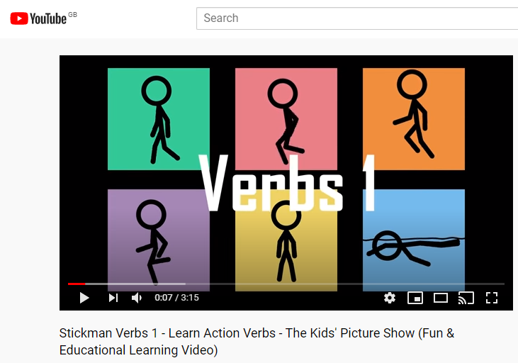

https://www.youtube.com/watch?v=v6CHa12QkQw
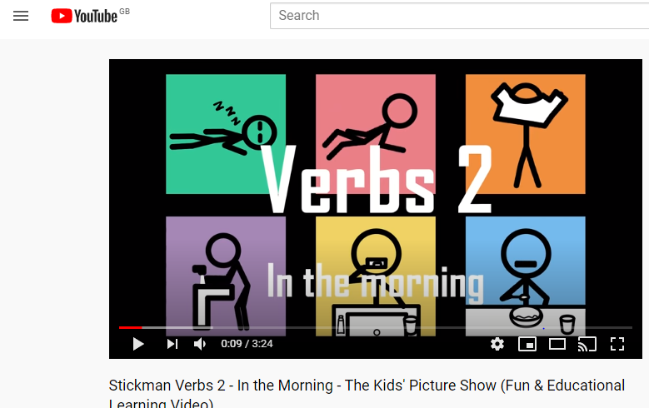

https://www.youtube.com/watch?v=lo2OMlGOXM8 (Stickman Action verbs 3- A)sports verbs
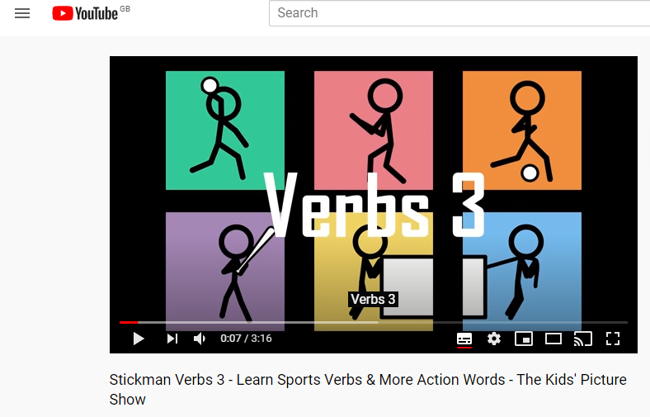

https://www.youtube.com/watch?v=ecxlISdoQH0
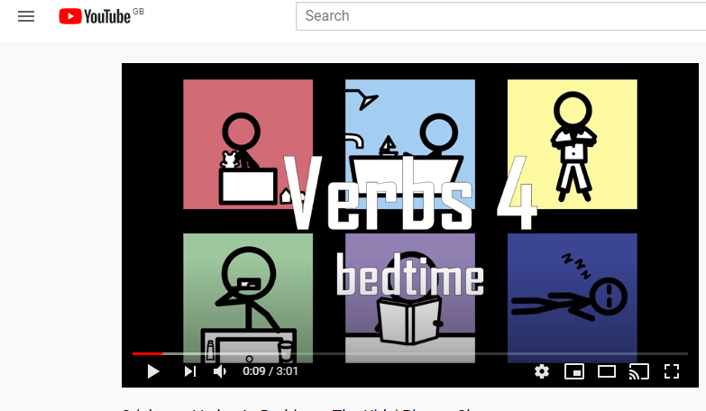

https://www.youtube.com/watch?v=n8qk5BIpP6U (colours-A)
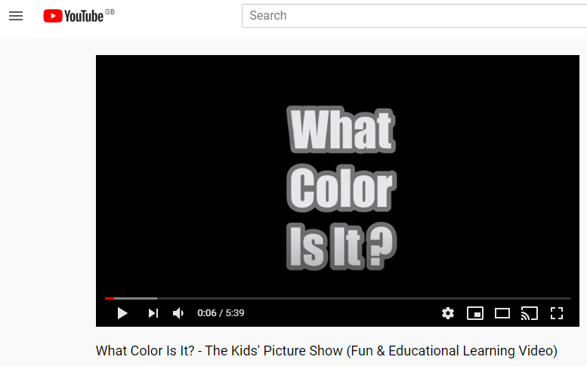

https://www.youtube.com/watch?v=NaNrzQUyuPQ (shapes-A)
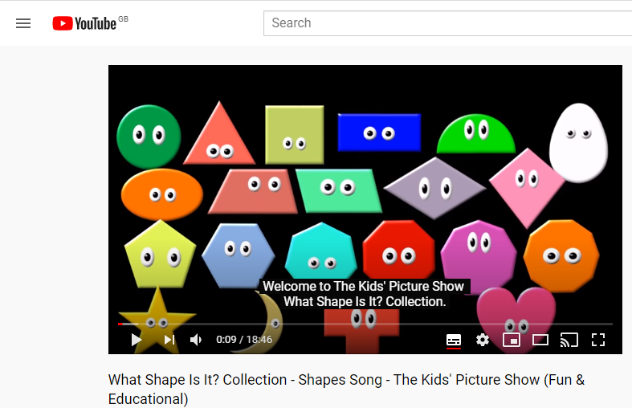

https://www.youtube.com/watch?v=6Dly8hArlNQ
Make sure you can spell all these words
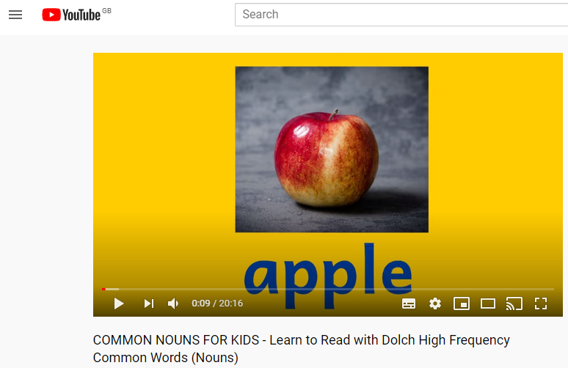

https://www.youtube.com/watch?v=Q9JJyfnbY6g

https://www.youtube.com/watch?v=XDR4EXIsQos
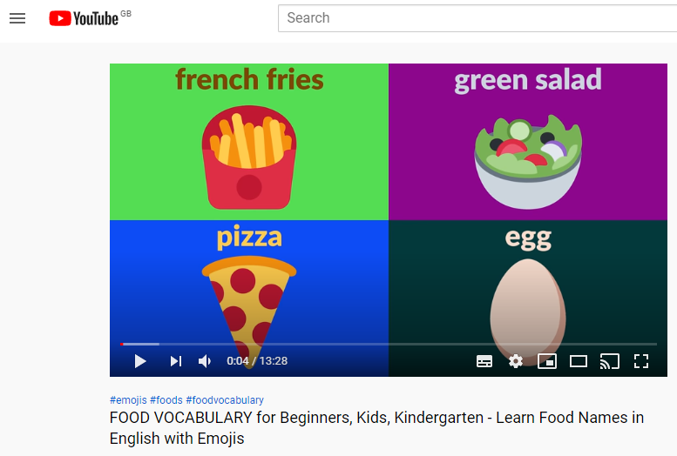

https://www.youtube.com/watch?v=STMMidLxRR4
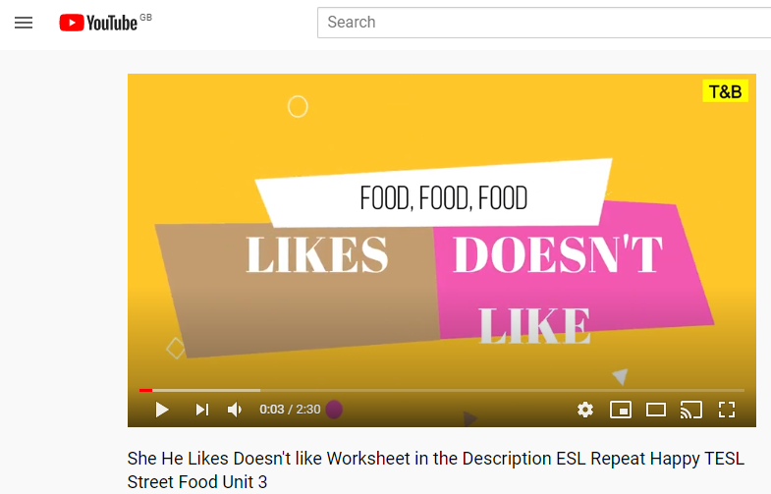

https://www.youtube.com/watch?v=AxPOEUwTBvc
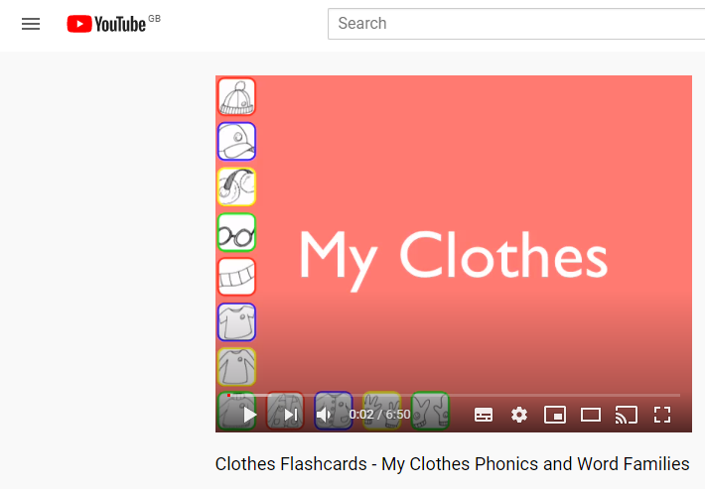

https://www.youtube.com/watch?v=Z2biA1gczXs (the weather -A)
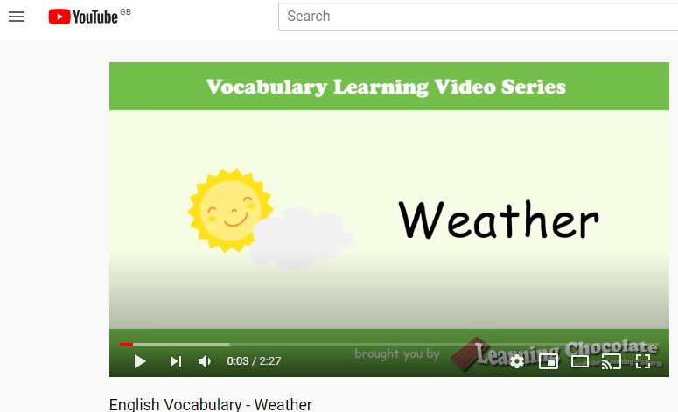

https://www.youtube.com/watch?v=1ld4GeQkYC0
