KEY STAGE 3 – ART
Instructions – Each task will take you at least an hour to complete, please pick and complete the task of your choice each week don’t forget to Email a picture of each completed task to your Art teacher.
TASK 1  Using a toilet roll tube, recreate a famous piece of art or make up your own. You can use whatever materials you want to. Take a photo of the finished piece. Here are some samples.  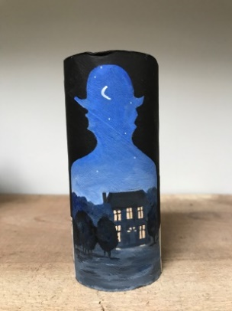  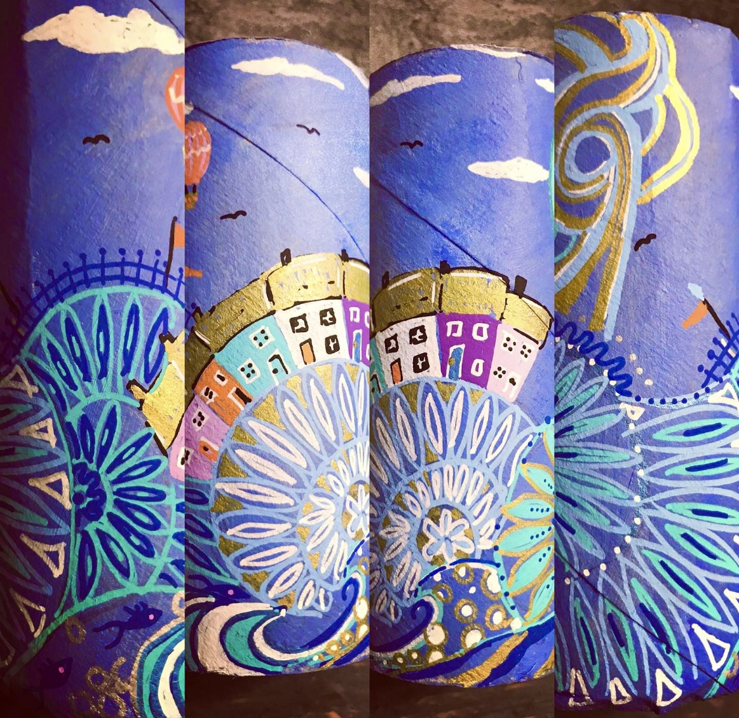 | TASK 2  Place a food item onto a piece of paper and transform it into something fun and quirky. Photograph the result.  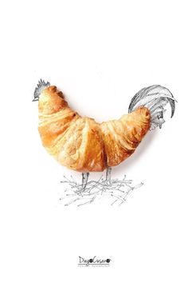  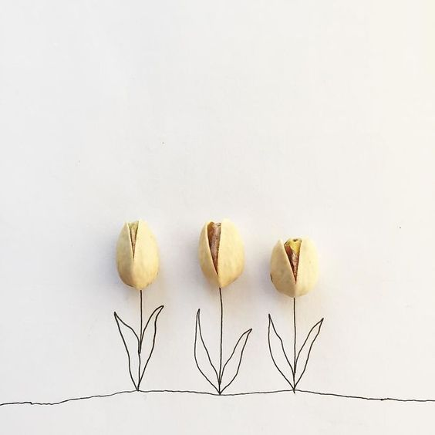 | TASK 3  Use magazines, photos or downloaded images to cut up and experiment with. Create new characters.  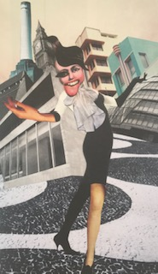  For more of a challenge, make a background too.  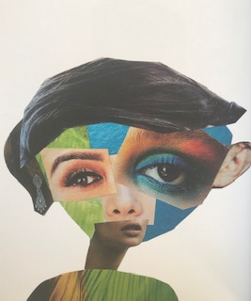 | TASK 4  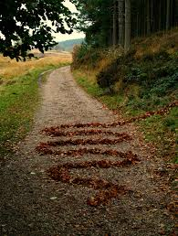  Create your own art in the style of Andy Goldsworthy. Look at his artwork to inspire you. He uses rocks, leaves and other forms of nature to make Art. Take a photo of your finished piece.  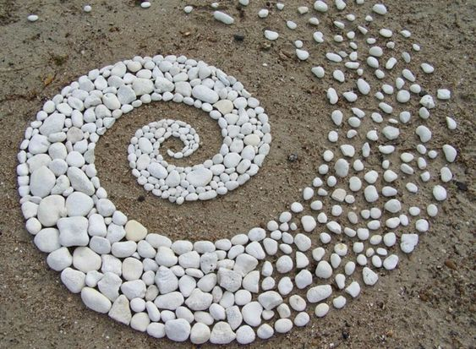
TASK 5  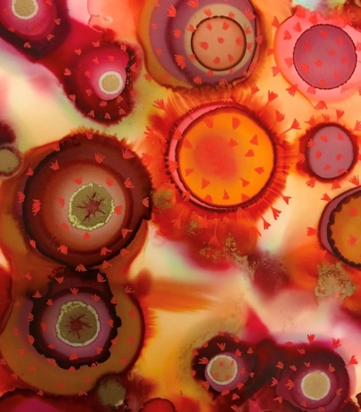  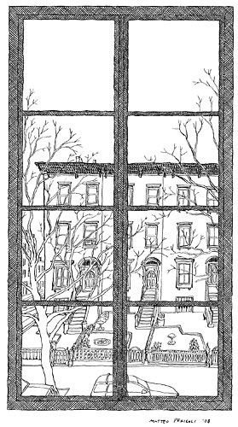  Make a piece of Art on the theme of lockdown. You may interpret this any way you like and use materials of your choice. Maybe draw the view from your window. The sample below is based on the virus. | TASK 6  Look at the work of Street Artist ‘My Dog Sighs’. Crush a can and paint an eye or animal on the can edge. Alternatively, paint onto a stone.  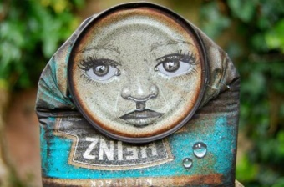  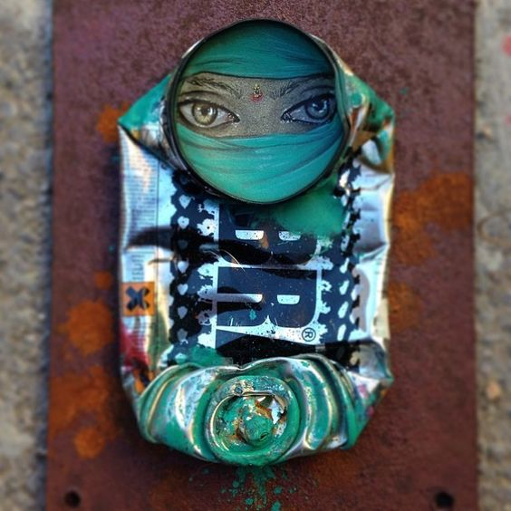 | TASK 7  Using tea or coffee, make a splat on a piece of paper and turn it into something creative.  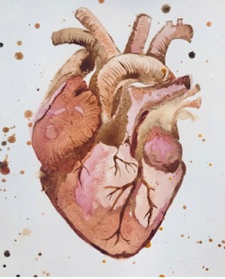  For more of a challenge, paint using natural ingredients. For the heart and pelvis, tea, coffee, turmeric, ginger and paprika have been used, for the heart, beetroot juice and balsamic vinegar are used..  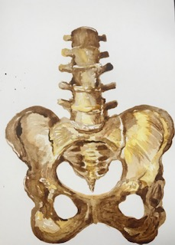  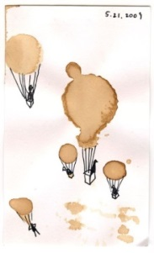 | TASK 8  Turkish artist Merve Ozaslan gives vintage photos a natural touch. Print off old photos, cut out sections and glue images of nature behind them. You could also use magazines.  Alternatively, cut a section from the photo and hold it up against a tree or cloudy sky, then photograph it.  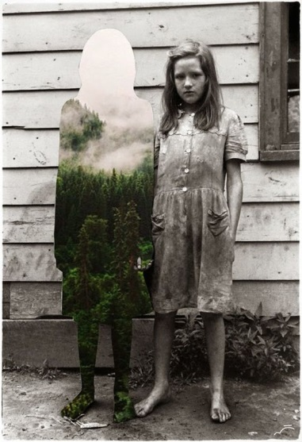  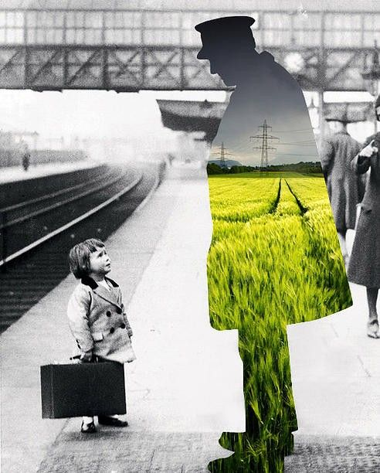
TASK 9  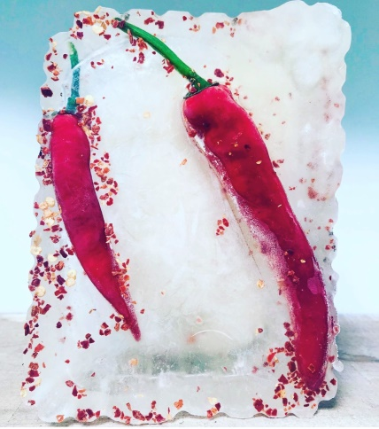  Use plastic food trays, fill them with flowers, leaves, sliced fruits etc and freeze them. Draw, paint or photograph the results. Here are some examples..  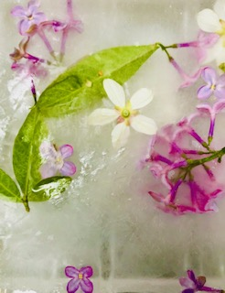 | TASK 10  Make a piece of Op Art.  Draw random shapes onto paper and create curved lines. See my examples below. Add colour using bright colours or leave it black and white. The choice is yours.  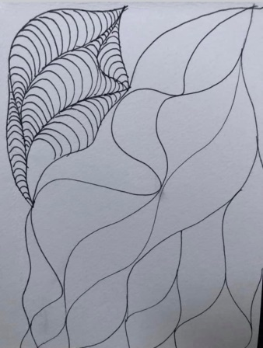  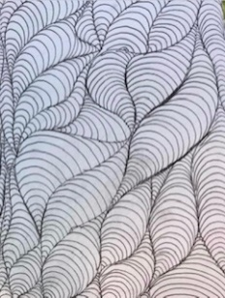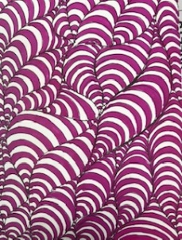 | TASK 11  Use masking tape or coloured tape to create a moveable shape to create optical illusions. Photograph your outcomes.  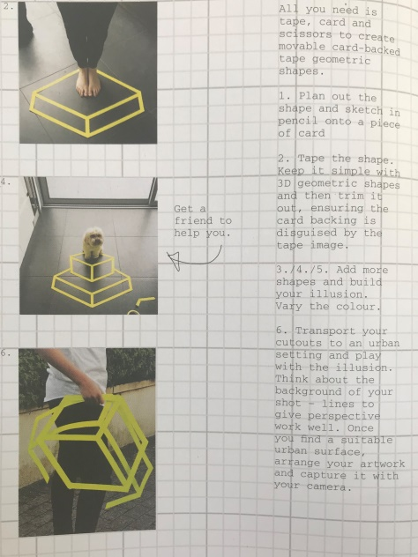  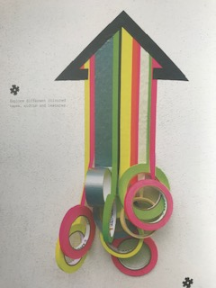 | TASK 12  Make a continuous line drawing. Here are some examples of mine ranging from easy to more challenging. Draw without lifting your pen off the paper. If you accidentally do, then start again where you left off.  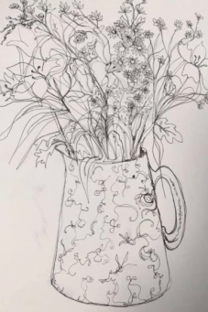  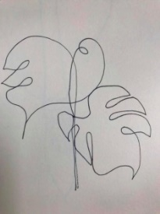  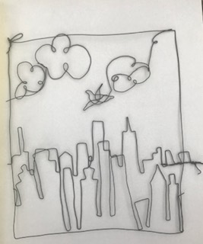  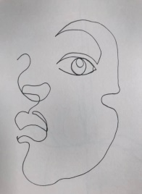  For a greater challenge, create a city scape with one long piece of string or wire.

